ASIC Pipeline Debug API
Arkadi Sharshevsky

Mellanox
Yokneam, Israel
arkadis@mellanox.com

Abstract

While doing the hardware offloading process much of the hardware specifics cannot be presented. One example is the routing LPM algorithm used by the Linux kernel which may differ from the hardware implementation. The new pipeline debug API (dpipe) is aiming at providing the user visibility into the ASIC’s pipeline in a generic way.

Keywords
Linux, ASIC, switch, offload, dpipe, UAPI.

Introduction
The hardware offload process is done in way that a user should barely distinguish between the hardware vs. software implementation. In this process the hardware specifics are neglected, but in reality those details can have lots of meaning and should be exposed in some standard way.

This problem becomes worse when one wishes to offload the control path of the whole networking stack to the switch ASIC. Due to the differences in the software/hardware models some processes cannot be presented correctly. One example is the kernel’s longest prefix match (LPM) algorithm which in many cases differs greatly from the hardware one. The configuration API is the same, but one cannot rely on the FIB to look like LPC-trie in hardware. In many situations trying to analyze systems failure solely based on the kernel’s dump may be not enough and should be combined with complementary information from the underlying hardware. This information can be also very useful when debugging performance issues. Furthermore it should be provided in vendor-neutral manner.

The interface called “dpipe” is proposed to close this gap. The hardware’s pipeline is modeled as graph of match/action tables, where each table represents specific hardware block. This model is not new and was first introduced by P4 [1] language. Similar approach was suggested by John Fastabend in the Flow API [2] patch-set. Traditionally it has been used as alternative model for hardware configuration, yet the intent is to use it for visibility purposes as standard complementary tool. The system’s view from dpipe’s perspective should change according to the changes done by the standard configuration tools. For example, it’s quiet common to implement ACL using TCAM memories. The TCAM memory can be divided into TCAM regions. Complex TC filter can have multiple rules with different priorities and different lookup keys. On the other hand hardware TCAM regions have a predefined lookup key. Offloading the TC filter rules using TCAM engine can result in multiple TCAM regions being interconnected in a chain (which may affect the data path latency). In response to new TC filter new tables should be created describing those regions. It is possible to create a tool based on dpipe for monitoring the TCAM occupancy which can be useful for complex debugging.

In the next section the model will be described in detail. Next, the abstraction of the L3 part of the Spectrum ASIC will be presented as an example. Finally future extensions will be discussed.

Model
The model introduces several objects which are headers, tables and entries. The headers describe packet formats and provide names for fields within the packet. The tables describe the hardware blocks. The entries describe the actual content of a specific table.

The hardware pipeline is not port specific but rather describes the whole ASIC, thus, it’s quiet convenient to put it on top of the Devlink infrastructure. In order to support dynamic behavior the driver can register/unregister the tables at runtime. The dynamic behavior is mandatory for describing hardware blocks like TCAM regions which can be allocated/freed dynamically. The only thing that can be configured partially is hardware counting for a specific table.

The following new commands were introduced to Devlink in order to access the dpipe objects from userspace:

- table_get - receive table’s description.
- headers_get - receive device’s supported headers.
- entries_get - receive table’s current entries.
- counters_set – enable/disable counters on a table.

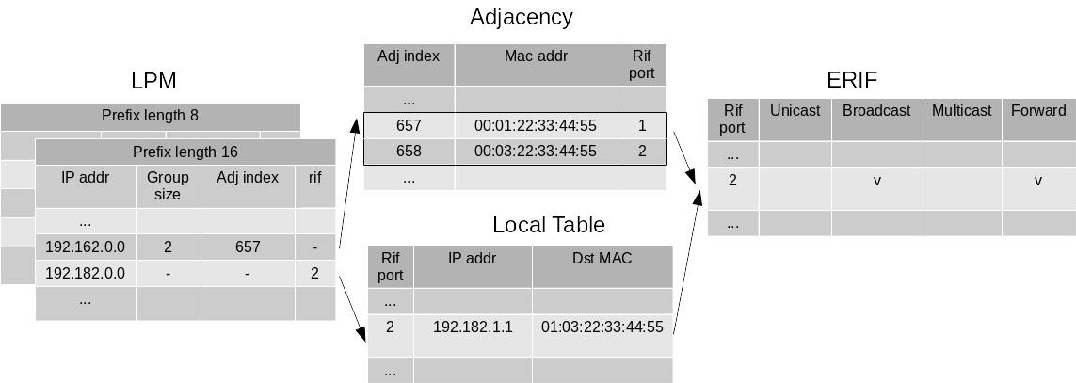
Figure 1. Describes the interactions between hardware tables.

In the rest of the section dpipe’s basic object will be discussed in detail.

Table
The driver should implement the following operations for each table :

- matches_dump - dump the supported matches.
- actions_dump - dump the supported actions.
- entries_dump - dump the actual content of the table.
- counters_set_update – synchronize hardware with counters enable/disable.

Header/Field
In a similar way to P4 the headers/fields are used to describe the table behavior. Yet, there is a difference between two cases which are standard protocol headers and specific ASIC metadata. The protocol headers should be declared once in the Devlink core. On the other hand the ASIC metadata is driver specific and should be defined in the driver. The headers/fields are identified by enumeration.
In order to provide further visibility some ASIC metadata fields could be mapped to some kernel objects. For example, internal router interface indexes can be directly mapped to net devices ifindex, FIB tables indexes used by different VRFs can also be mapped to internal routing table indexes, etc.

Match
Matches are kept primitive and close to hardware operation. Match types like LPM are not supported due to the fact that this is exactly a process we wish to describe in full details. Examples of matches:

- field_exact - exact match on a specific field.
- field_exact_mask - exact match on field after masking.
- field_range - match on specific range.

The id’s of the header and the field should be specified in order to identify the specific field. Furthermore the header index should be specified in order to distinguish multiple headers of the same type in a packet (tunneling).

Action
Similar to match, kept primitive and close to hardware operation. For example:

- field_modify – modify field value.
- field_inc – increment field value.
- push_header – add header.
- pop_header – remove header.

Entry
Describes specific table entry. Entries of specific table can be dumped on demand. Each entry is identified with index and its properties are described by a list of match/action values and specific counter. By dumping the tables content the interactions between tables can be resolved.

Abstraction Example
As an example of this abstraction model the L3 part of Mellanox Spectrum ASIC will be modeled. The blocks are described in the order they appear in the pipeline. A visualization is provided in Figure 1. The table sizes in the following examples are not real hardware sizes and are provided for demonstration purposes only.

LPM
The LPM algorithm can be implemented as a list of hash tables. Each hash table contains routes with the same prefix length. The root of the list is /32, in case of a miss the hardware will continue to the next hash table. The depth of the search will affect the data path latency.
In case of a hit the entry contains information about the next stage of the pipeline which resolves the MAC address. The next stage can be either local host table for directly connected routes, or adjacency table for next-hops. Please refer to Listing 1 as an example for a table representing prefix /16. The meta.lpm_prefix field is used to connect two LPM tables.
table lpm_prefix_16 {
size: 4096,
counters_enabled: true,
match : { meta.vr_id :exact,
ipv4.dst_addr: exact_mask,
ipv6.dst_addr: exact_mask,
meta.lpm_prefix: exact },
action : { meta.adj_index: set,
meta.adj_group_size: set,
meta.rif_port: set,
meta.lpm_prefix: set },
}
Listing 1. IPv4/6 table example.

Local host
In case of local routes the LPM lookup already resolves the egress router interface (RIF), yet the exact MAC address is not known. The local host table is a hash table combining output interface id with destination IP address as a key. The result is the MAC address.
table local_host {
size: 4096,
counters_enabled: true,
match: { meta.rif_port: exact,
ipv4.dst_addr: exact},
action: { ethernet.daddr: set}
}
Listing 2. Local host table example.

Adjacency
In case of remote routes this table does the ECMP. The LPM lookup results in ECMP group size and index that serves as a global offset into this table. Concurrently a hash of the packet is generated. Based on the ECMP group size and the packet’s hash a local offset is generated. Multiple LPM entries can point to the same adjacency group.
table adjacency {
size: 4096,
counters_enabled: true,
match: { meta.adj_index: exact,
mata.adj_group_size: exact,
meta.packet_hash_index: exact },
action: { ethernet.daddr: set,
meta.erif: set }
}
Listing 3. Adjacency table example.

ERIF
In case the egress RIF and destination MAC have been resolved by previous tables this table does multiple operations like TTL decrease and MTU check. Then the decision of forward/drop is taken and the port L3 statistics are updated based on the packet’s type (broadcast, unicast or multicast).
table erif {
size: 800,
counters_enabled: true,
match: { meta.rif_port: exact,
meta.is_l3_unicast: exact,
meta.is_l3_broadcast: exact,
meta.is_l3_multicast: exact},
action: { meta.l3_drop: set,
meta.l3_forward: set }
Listing 4. ERIF table example.

Future Extensions
From the LPM example it is clear that table nesting should be introduced. That is not surprising due to the fact that hardware is modeled in a nested way. The ASIC can be decomposed into top tables representing L2/L3 blocks. The top tables can be further zoomed in. By introducing nesting the user will be able to focus on a specific hardware block of interest.
Several tables can share resources. For example, unified hash-based memory can be used for many lookup purposes. By modeling the “resource” object further visibility can be achieved in order to debug ASIC-wide issues.
Conclusion
The interface called “dpipe” was proposed to add visibility into the hardware offload process. Its design decisions and details were presented. In order to validate its extensibility
a real hardware block was modeled and future extensions were introduced.

Acknowledgements
Thanks belong to Jiří Pírko and Matty Kadosh for the review.

References

[1] Pat Bosshard, Dan Daly, Glen Bibb, et. al., “P4: programming protocol-independent packet processor” ACM SIGCOMM Computer Communication Review Volume 44 Issue 3, (July 2014): 87-95
[2] Fastabend, J. 2015. A flow api for linux hardware devices. http://people.netfilter.org/pablo/netdev0.1/papers/A-Flow-API-for-Linux-Hardware-Devices.pdf

Author Biography

Arkadi Sharshevsky is a Linux kernel developer employed by Mellanox. He is an active contributor to the Mellanox Linux upstream switch driver (mlxsw).

